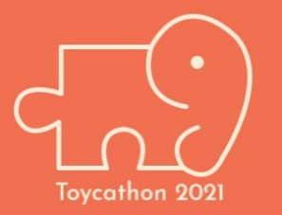
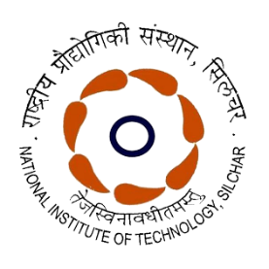
राष्ट्रीय प्रौद्योगिकी संस्थान सिलचर
NATIONAL INSTITUTE OF TECHNOLOGY SILCHAR
Toycathon 2021
Grand Finale of Digital Edition
22-24th June 2021
NIT Silchar: Nodal Centre, Assam
List of Participants
SL. No. | Idea ID | Category | Team Name | Team Leader Name
1 | 12763 | Digital | Loop Slayers | Anant Kumar Sharma
2 | 8134 | Digital | Alphaconcept | Sourya Shome
3 | 8499 | Digital | Mythical PHOENIX | Sourasish Nath
4 | 9750 | Digital | The Hanu-G | Agniswar Bhattacharjee
5 | 9832 | Digital | The Gamios | SOUMYARUP NAIYA
6 | 11025 | Digital | Buddhi Yoga | Aman gopal sureka
7 | 11242 | Digital | Sankalp | Arpan Chatterjee
8 | 11548 | Digital | Learn To play | Adrita Mahata
9 | 11683 | Digital | She-Unit | Rishita Das
10 | 11715 | Digital | ABVBTechies | Smriti Singh
11 | 12176 | Digital | Kautilya Savvy | Priyam Pal
12 | 12340 | Digital | Omkara | Ankita Das
13 | 12438 | Digital | Neo Conformists | Saswati Biswas
14 | 12671 | Digital | EKYAM | Sayantan Dutta
14 | 12944 | Digital | Craftsmen | Shweta Mishra
16 | 15492 | Digital | GEN-Z | ANUSWETA ROY
17 | 16414 | Digital | Team Alpha India | Sameer Alam
18 | 11374 | Digital | cuRIO | Ankita Chowdhury

*****

